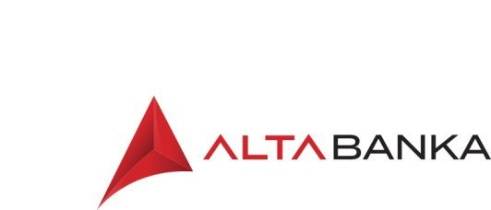 | Prigovor za fizička lica / Complaint Form - natural persons
 | Šifra: OBR-124 | Verzija: 8 | Strana: 1/1

Ime i prezime / Name and Surname:
JMBG / Unique Citizen Identification Number:
Adresa / Address:
Pravni osnov / Legal basis:
Opis spornog odnosa / Description of the disputable relation:

Napomena: Ukoliko ne budete zadovoljni odgovorom ALTA Banke a.d. Beograd, možete se obratiti Narodnoj banci Srbije, Sektor za zaštitu korisnika finansijskih usluga na adresu:
Note: If you are not satisfied with the reply of ALTA banka a.d. Beograd, you may contact the National Bank of Serbia, Department for Financial Consumer Protection at the address:
- Nemanjina 17 11000 Beograd ili poštanski fah 712, 11000 Beograd,/ Nemanjina 17, 11000 Beograd, or P.O.BOX 712, 11000 Belgrade ili/or
elektronskim putem: preko web forme na početnoj stranici internet prezentacije NBS, deo: Podnesite pritužbu/prigovoru na rad davaoca finansijskih usluga/trough the web form on the homepage of the NBS website, part: Submit a complaint about the work of a financial service provider.

U Beogradu/ Potpis/Signature
In Belgrade, godine/year

Bulevar Zorana Đin ića 121 • 11070 Beograd • Poštanski fah 59 • PAK 190347 • Tel.: 2205-500 • Fax: 311-0217
E-mail: info@altabanka.rs • Web: www.altabanka.rs• SWIFT: JMBNRSBG

