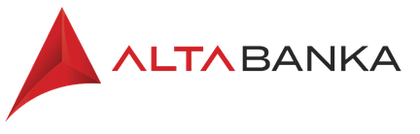

Good afternoon, we are pleased that you are applying to open an account at Alta Banka!

Please fill out the questionnaire below in detail:

- Please state the purpose of opening the account:

- Your occupation and what you do now ?

- Do you have a company in Serbia or are you planning to open one? If you have one, state the name and PIB

- Are you planning a longer stay in Serbia and registering for residence?

- Are you planning to buy real estate in Serbia?

- How much money will arrive in the account per month? Who will send the money (employer or other transfers)

- Do you plan to make cash payments to the account? If the answer is yes, in what amount, from which country, from whom (mandatory delivery of account statement with balance and account owner's passport)

Please mark the category you belong to:
 | STUDENT | UNEMPLOYED/ FREELANCE | IN EMPLOYMENT
needed documents  and iniformations | Information about parents (parent information name, surname, middle name), Name of the college being studied and location | Previous work experience, company name | Employment contract submitted
 |  | From whom do you expect payments, in what amount, from which country? Necessary delivery of a photocopy of the passport of the person who will pay the money and an account statement with the balance
Other:

